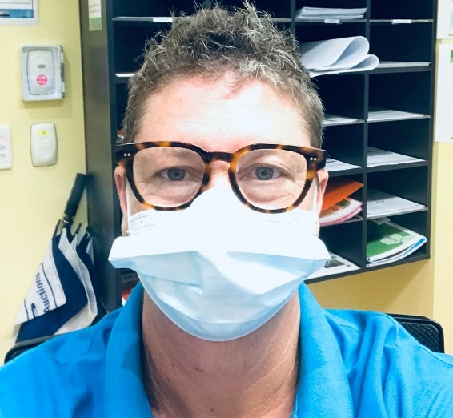
Cal Gordon MacKinnon

Cal is a currently a third year Bachelor of Nursing student and has had a career in the arts as a photographer, poet and multimedia artist. His solo exhibitions include Solo shows at Stills Gallery Sydney, The Victorian Arts Centre, Gold Coast, Lismore, and Grafton Regional Galleries, with works in collections locally and worldwide.
Cal has collaborated with poetry collectives, Flying Arts QLD and including others has worked extensively with the Gold Coast City Council Heritage Department publishing a series of postcards and books.
Cal is due to finish his Nursing degree this year and plans to work in mental health specialising in suicide prevention within the LGBTQI community.
Cal is due to finish his Nursing degree this year and plans to work in mental health specialising in suicide prevention within the LGBTQI community.

